Xidian University & Heriot-Watt University

**Labratory 3 - Matching Circuit Design**

(B39HF | B31HD)

High Frequency Circuit Design

**Team Members:**

|  |  |  |
| --- | --- | --- |
| Name | XDU ID | HWU ID |
| Wenchuan Zhang | 21012100092 | H00392711 |
| Yirui Fu | 21012100086 | H00392656 |
| Fengliang Mi | 21012100040 | H00392671 |
| Yihong Yang | 21012100009 | H00392658 |
| Yiqian Zhang | 21012100052 | H00393159 |
| Zhuoyu Wu | 21012100038 | H00392691 |
| Xunchi Ma | 21012100015 | H00392669 |
| Yang Yu | 21012100011 | H00392718 |

**1. Introduction**

ADS software provides a wealth of capabilities and tools for circuit simulation, electromagnetic simulation, mixed-signal simulation, system-level simulation, and more to help engineers design, optimize, and validate a wide range of electronic devices and systems. It supports a variety of model libraries, including various device models and transmission line models, while also providing powerful layout and routing tools.

The primary goal of this experiment is to increase understanding and familiarity by using ADS software. Secondly, the experiment aims to design and simulate a high-frequency circuit, including a quarter wave matching segment, and evaluate the performance of the designed circuit using a vector network analyzer (VNA) based on a USB interface.

**2. Theory**

The working principle of the quarter-wavelength transformer is based on the principle of impedance matching, which realizes the transmission and conversion of electrical energy by matching the impedance of the input and output ports.

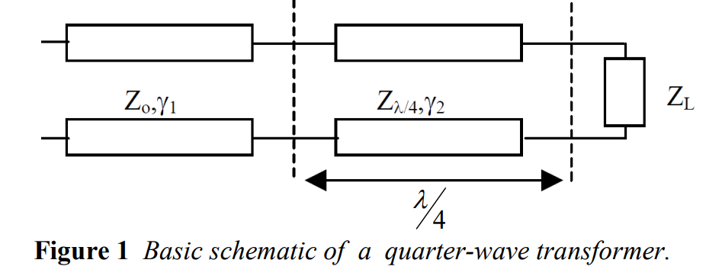

According to the input impedance, the corresponding $Γ_{in}$ is

$$Γ_{in}=\frac{Z_{in}−Z_{0}}{Z_{in}+Z_{0}}$$

To match the impedance, $Γ_{in}=0,$ $Z_{in}=Z_{0}$,

$$Z_{in}=\frac{Z_{λ/4}^{2}}{Z_{L}}=Z_{0}; Z_{λ/4}=\sqrt{Z_{0}Z_{L}}$$

A Microstrip is a commonly used high-frequency transmission line whose structure consists of a flat conductor line and a large ground parallel to it. Microstrip line is a kind of transmission line that is easy to manufacture and design and can be widely used in microwave circuits.

The width and length of microstrip wire are two important parameters that affect its electrical properties. The width determines the impedance of the microstrip line, and the length determines the transmission characteristics of the microstrip line, such as transmission loss and group delay.

For a microstrip line with a common dielectric constant, its width can be calculated by the following formula:

$$W=\frac{2h}{\sqrt{ε_{r}+1}}×\left[\frac{ε_{r}+1}{2ε_{r}}+\frac{1}{2}\left(\frac{ε_{r}−1}{ε_{r}+1}\right)×{\left(1+\frac{12h}{W}\right)}^{−\frac{1}{2}}\right]$$

Where $W$ is the width of the microstrip line, $h$ is the thickness of the microstrip line, and $ε_{r}$ is the relative dielectric constant of the medium.

For a given operating frequency, after determining the impedance of the microstrip line, the length of the microstrip line can be calculated using the following formula:

$$L=\frac{v_{Ph}}{2f}×\left(\frac{l}{λ}+\frac{λ}{4h}\right)$$

Where $L$ is the length of the microstrip line, $v_{Ph}$ is the phase speed, $f$ is the operating frequency, $l$ is the electrical length when the microstrip line is open at both ends, λ is the propagation wavelength, and $h$ is the thickness of the microstrip line.

Phase Velocity is the speed at which the wave crest or trough moves as the electromagnetic wave propagates through the medium. The phase velocity can be expressed by the following formula:

$$v_{ph}=\frac{ω}{k}=\frac{c}{\sqrt{ε_{r}}}$$

Where $v_{ph}$ is the phase velocity, ω is the angular frequency, $k$ is the wave vector, $c$ is the speed of light, and $ε_{r}$ is the relative permittivity of the medium.

In microwave circuit design, it is usually necessary to select the appropriate width and length of the microstrip line according to specific design requirements, such as impedance matching, transmission loss and group delay.

Vector network analyzer (VNA) is a test instrument for measuring electrical network parameters. They are essential for the analysis of radio frequency (RF) and microwave components in a variety of passive and active devices, including filters, antennas, and power amplifiers. Network analyzers are ideal for transmission, reflection and impedance measurements as well as S-parameter measurements during design and production.

S-parameters have always occupied the most important position in microwave theory and technology, and they include measurement items that have long been familiar to engineers, such as S11 (input matching), S22 (output matching), S21 (gain/loss), S12 (isolation), etc., and the test results of these measurement items can be easily imported into electronic simulation tools.

In the case of impedance matching, $s11=\left|Γ\right|$

$$S11\left(ⅆB\right)=20\lg\left(\left|S11\right|\right)=−RL$$

Specifically, if the impedance matching is well realized, then the reflection loss RL should be small, that is, the power loss of the reflected signal is small; The scattering parameter S11 should also be small, that is, the intensity of the reflected signal is small. Under normal circumstances, RL should be greater than 10 dB, S11 should be less than -10 dB, so as to ensure that the impedance matching achieves better results.

1. **Procedure or Experimental Method**

1. Launch Keysight Advanced Design System (ADS).

2. Initiate a new project and open a schematic design interface (navigate: Window — New Schematic). During setup in the Workspace Wizard, measurements are to be set in millimetres, not mils. The option chosen should be: “Standard ADS Layers, 0.0001 millimetre layout resolution”.

3. The schematic interface features an element toolbar on the left, containing various lumped elements for incorporation into the schematic. Experimentation with these elements, such as a resistor, can be conducted by selecting the resistor icon, placing it on the schematic with the left mouse click, and pressing 'escape' to cease adding resistors. The resistor’s value is adjusted to 100 Ohm by double-clicking on it.

4. Familiarity with the interface allows for the switching between different element libraries using the dropdown menu above the element toolbar, which defaults to the “Lumped – Components” library. Switching to the Tlines-Microstrip library to access microstrip components is done next. This involves adding two microstrip lines (MLIN) and a microstrip substrate (MSUB) to the design. The microstrip substrate parameters are set to FR4 with specific characteristics (Er = 4.3, tan(d) = 0.019, thickness = 1.6 mm), while other settings are left as default.

5. The library is then changed to Simulation-S-param, and a port, a terminal (TERM), a ground connection, and an S parameter simulation block (SP) are placed. Figure 2 serves as a guide for locating the port and ground. The start, stop, and step frequencies for the S parameter simulation are configured as considered appropriate. ‘Term1’ is set to an impedance of 50 ohms, indicating the reference impedance for the system.

6. The simulation components are connected using wires, which are accessible through the Component—Wire library or by selecting the wire tool.

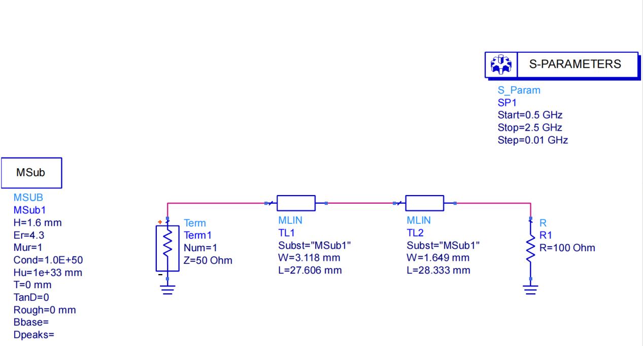

**Figure 2** *Schematic Window and Libraries / Elements*

7. Using equations given in class and this lab guide, find the required impedance for a quarter-wave transformer to match a 50 Ω transmission line to a 100 Ω load at 1.5 GHz.

the required impedance

8. Access the LineCalc tool through Tools – LineCalc – Start LineCalc. LineCalc (refer to Fig. 3) is utilized for calculating the dimensions of transmission lines based on substrate parameters and the frequency of operation.

a. Set the Type to MLIN and the Substrate Parameters to ID MSUB_DEFAULT.

b. Configure the dielectric constant to match FR4 specifications (Er = 4.3, tan(d) = 0.019, thickness = 1.6 mm).

c. Adjust the frequency setting to 1.5 GHz.

d. Verify that all other parameters correspond with the MSUB1 parameters displayed in the schematic window.

e. In the ‘Electrical’ Section, input ZO = 50 (impedance in ohms) and E_Eff = 90 (electric length in degrees).

f. Use the ‘Synthesize’ button to calculate the necessary width and length for a 50 Ω transmission line that measures 90 degrees in length, based on the substrate defined in the previous steps.

g. Upon clicking the Synthesize button, the analysis will execute, resulting in the display of width (W) and length (L) values in the “Physical” section.

h. Return to the schematic window and input the computed L and W values into the MLIN1 element (the 50 ohm line).

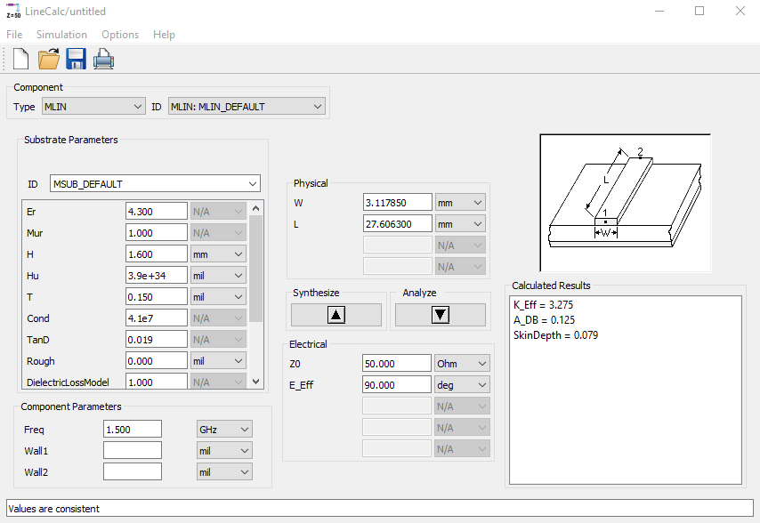

**Figure 3** *LineCalc window showing microstrip calculations*

9. Apply the method described in step 8 to ascertain the dimensions of the matching section, which has the impedance calculated in part 7. Input “90” in the E_Eff box to calculate the length of the quarter-wave section. This represents a length that is 90 degrees long, equivalent to λ/4.

10. After completing the design, save the work. The system is then simulated by selecting Simulate, pressing F7, or clicking the Simulate icon (depicted as a spinning gear) in the toolbox.

11. Plot the result by opening a new data display (**Simulate — New Data Display**, or pressing the graph icon on the toolbox). In the new window that pops up (Fig. 4), select **Insert — Plot**, then insert the square box in the blank display by clicking. Select S11, click “Add”, then chose “dB”. Select “OK”, and the plot of S11 will be displayed. Note the frequencies at which the circuit is matched. Is this what you expected? Explain.

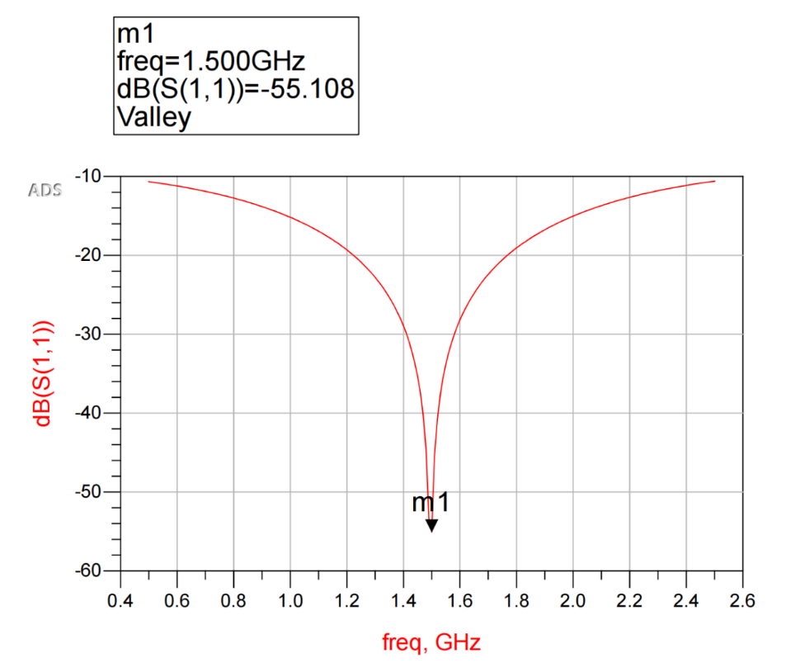

**Figure 4** *S-parameter plot*

Yes, the result we was expecting was that the minimum value of the S11 image appeared at the 1.5 GHz frequency. In the previous steps 8 and 9, we chose 1.5 Ghz as one of the parameters to generate the corresponding length and width of the microstrip line. The final circuit should also achieve impedance matching at 1.5 GHz, resulting in a minimum S11. Therefore, we can conclude that 1.5GHz is the best impedance-matching frequency for this circuit.

12. Tweak the parameters of the matching network to achieve a match at 1.5 GHz if necessary. Plot the result. Account for the differences in the predicted and previously observed results.

13. This part of the lab involves designing a WLAN communication system that incorporates two antennas operating in parallel (refer to Fig. 5). These antennas are modeled using equivalent circuits with impedances ZL1 = 82 Ω and ZL2 = 36 Ω. The objective is to match these loads to a transmitter having an internal impedance Zg = Zo = 50 Ω.

- In ADS, create a matching network that consists of two quarter-wave transformers (MLIN). This network aims to achieve an input impedance (Zin) of 50 Ω at the transmitter, which is represented as Port 1.

- The substrate used for this design is FR4, as specified earlier in the lab guide.

- It is important to consider that Zin1 and Zin2, the input impedances of the two antennas, are in parallel.

- The design frequency depends on the group number. For instance, if the group number is #X, the design frequency is set to 1.X GHz. Specifically, for group #3, the design frequency is 1.3 GHz.

- Ensure that the length of TL3 (one of the transmission lines in the matching network) is at least 3 cm. This minimum length is crucial to provide adequate space for connector soldering at each of the four ports.

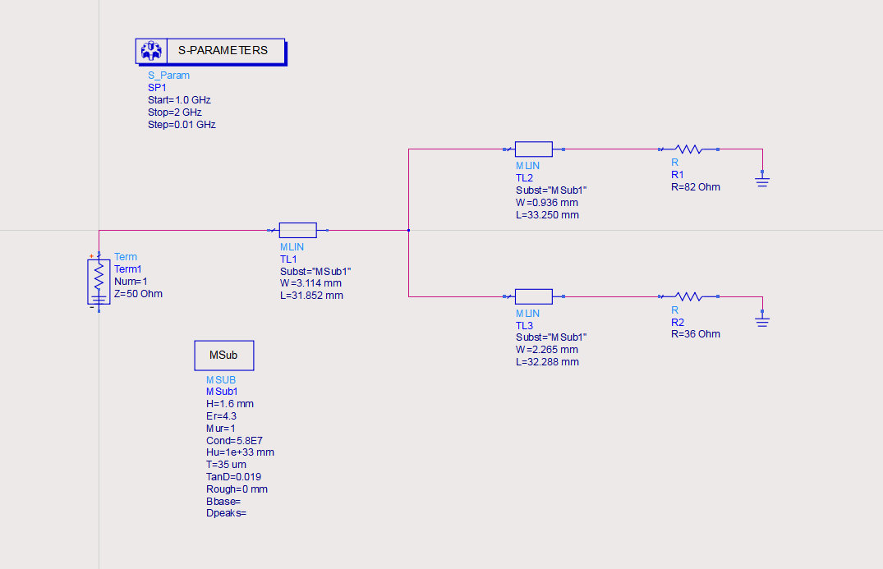

**Figure 5** *Representative Wireless Local Area Network (WLAN) Communication System*

14. Implement the WLAN circuit and simulate its frequency response in terms of S11.

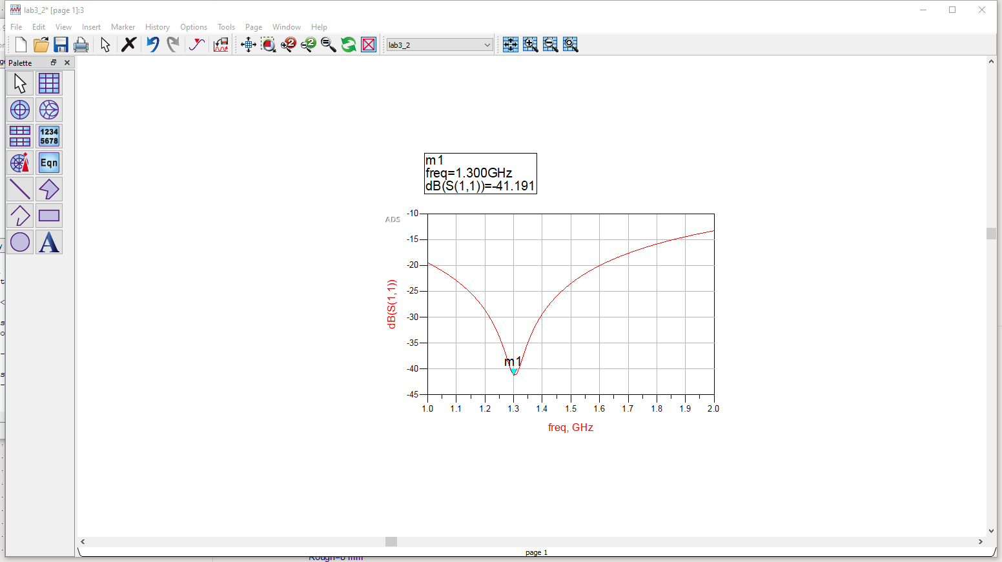

**Figure 6** *the frequency response in terms of S11*

15. The subsequent phase in the circuit design entails generating the layout, which represents the physical realization of the matching circuit through coordinates of metallization. This layout is then processed using another ADS module called Momentum. Momentum conducts a full-wave simulation by solving Maxwell’s equations, employing a numerical technique known as the method of moments. The intricacies of this process are beyond the scope of this course and won't be extensively covered in the lab. It's important to understand that Momentum discretizes the metal into a finite number of points (a mesh) and then applies Maxwell’s equations during a full-wave simulation.

16. The initial step in this phase is to create a Momentum layout of the schematic. This is done by selecting Layout Generate/Update Layout and accepting any dialogue boxes that appear. A new Momentum window will open, displaying the artwork associated with the design, as depicted in Fig. 7.

17. Upon examining the generated layout structure (refer to Fig. 7), discrepancies may be noticed, such as misplaced physical connections between TL1, TL2, and TL3. This issue can be rectified by incorporating a microstrip T-junction (MTEE) and two transmission line corner bends (MCORN) into the circuit schematic, as illustrated in Fig. 7.

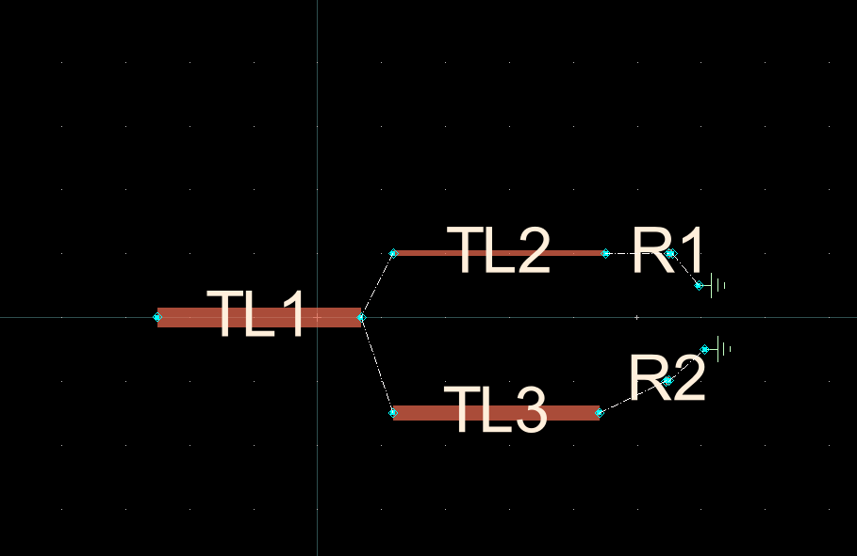

**Figure 7** *Momentum layout of the matching circuit*

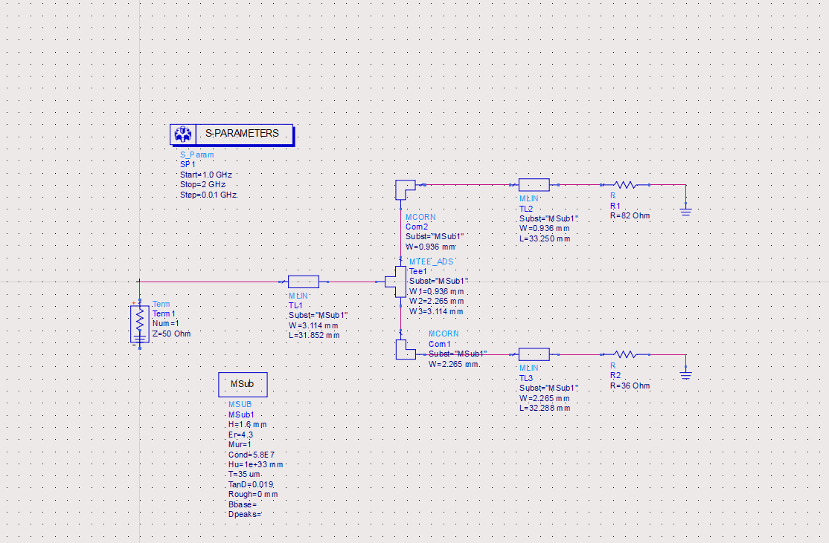

**Figure 8** *WLAN circuit with bends and a microstrip T-Section*

18. After modifying the circuit layout, re-simulate the design in the schematic window and document the outcomes. It's likely that the inclusion of the microstrip T-junction (MTEE) and transmission line corner bends (MCORN) has caused a shift in the minimum of S11, a parameter indicating how well the input is matched to the source impedance. This shift necessitates further optimization of the circuit to ensure that the desired design frequency is still achieved. Adjustments should be made in the schematic window to fine-tune the circuit. This process should be repeated until satisfactory results are obtained. During this optimization phase, consider utilizing other types of transmission line bends, T-section elements, and similar components to achieve the best possible design.

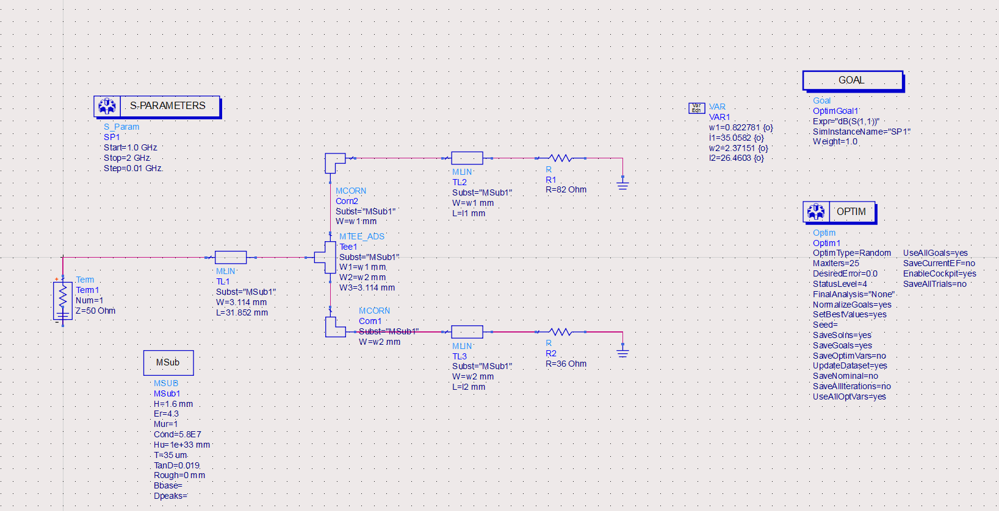

**Figure 9** *Developed* *WLAN circuit*

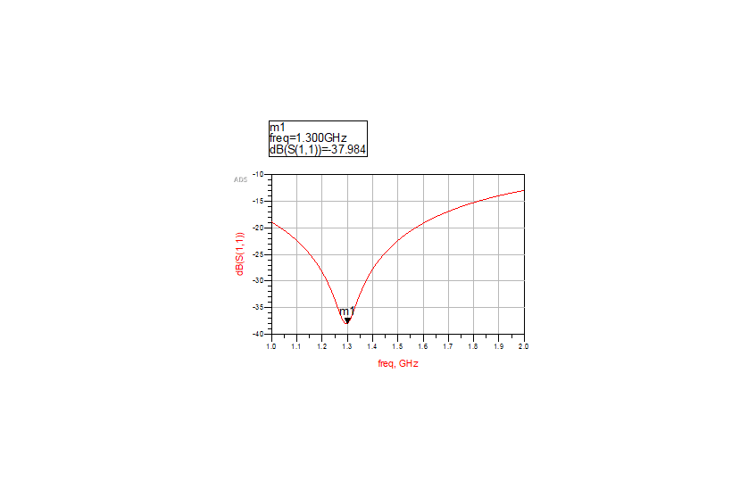

**Figure 10** *S-parameter plot after adding the MTEE and MCORN*

19. Once completed the previous step, re-generate the momentum layout of circuit， delete and ports, resistors blocks, and ground connections at this stage.

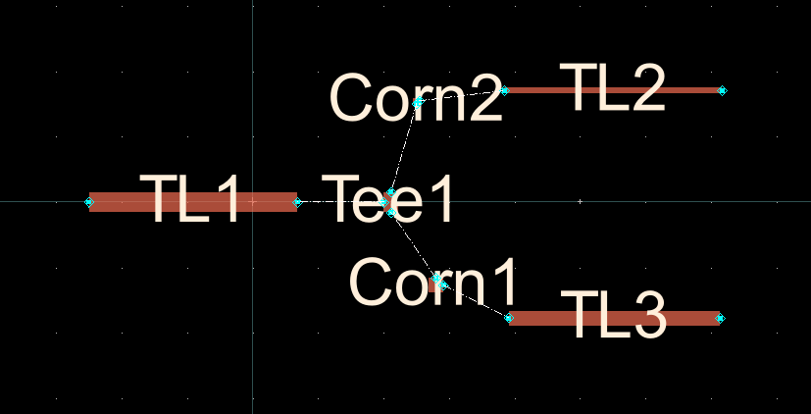

**Figure 11** *Momentum layout of the matching circuit.*

**4. Measurement:**

Using the provided lab kits, measure the matching circuit and compare with your simulation results. Prior to your measurements, ensure that your VNA has been properly calibrated.

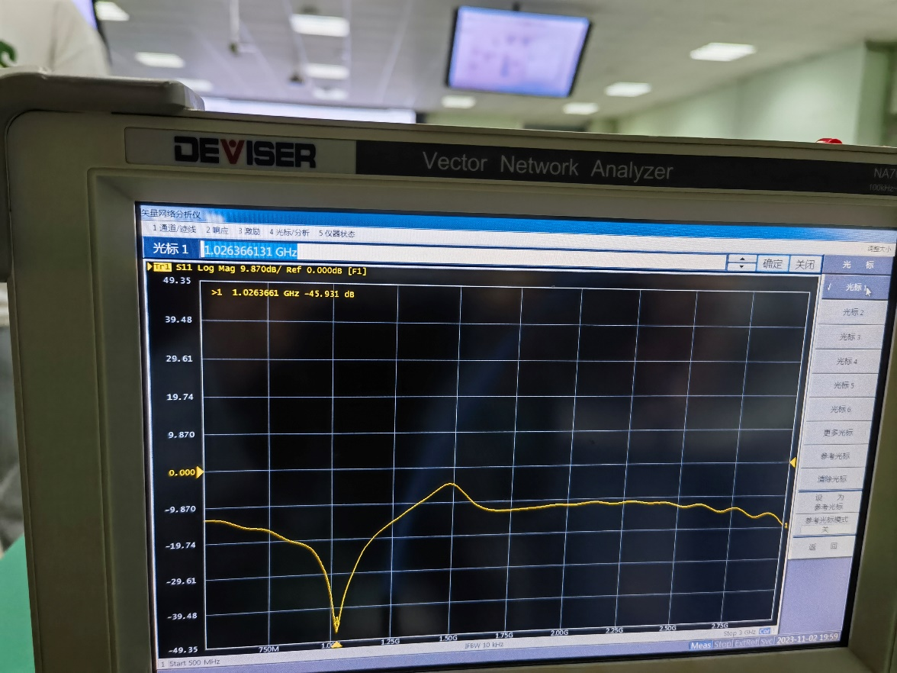

**Figure 12** *Observation result*

**5. Analysis and Discussion of Results**

The simulation result using ADS is that S11 reaches the minimum at 1.3Ghz to achieve impedance matching, but the actual result using the vector network analyzer reaches the minimum at 1.026Ghz. The reasons for this difference may include:

1. Inaccurate model: The component model or parameters used by the ADS may differ from the actual device, causing the simulation results to be inconsistent with the actual measurement results. In this case, you can try to use a more accurate model or adjust the component parameters to get a simulation that is closer to the actual situation.
2. Environmental effects: In the actual test, environmental factors (such as wiring, grounding, interference, etc.) may have an impact on signal transmission that are not considered in the simulation. Therefore, in the simulation, we should try to simulate the actual test environment, and consider the impact of environmental factors.
3. Measurement errors: The vector network analyzer used in the actual measurement may also have measurement errors, such as calibration errors, wire losses, noise, etc. These errors may lead to differences between the actual measurement results and the simulated results. When evaluating actual results, the impact of measurement errors needs to be taken into account and calibrated and corrected accordingly.

Improvements can include the following:

1. Verify model accuracy: Verify the component model and parameters used to ensure that they match the actual device. The accuracy of the model can be verified by comparing it with other reliable data sources or by conducting real-world tests.
2. Consider environmental factors: try to simulate the actual test environment in the simulation, and consider the impact of possible environmental factors on signal transmission. For example, details such as wiring, grounding, etc. are added to more accurately simulate the actual situation.
3. Calibration and correction of measurement results: If there is a large error in the actual measurement results, calibration and correction can be performed. Through accurate calibration of vector network analyzer, reducing wire loss and considering noise, the measurement accuracy is improved.
4. Optimize design: Optimize design based on actual measurement results combined with simulation data. Different matching network topologies, parameter adjustments, etc. can be tried to improve impedance matching performance.

**6. Conclusions**

This experiment aims to give students an understanding of the principles and methods of matching network design in high-frequency circuits through circuit design and simulation using ADS software, and practical measurement using VNA. The steps include creating the project, placing the components, setting the microstrip line media parameters, adding simulation components and parameters, determining the width and length of the microstrip line using the LineCalc tool, implementing matching circuits, and simulating their frequency response, generating circuit layouts and conducting full-wave simulations using the Momentum module. Finally, the matching circuit is measured by the experimental suite and compared with the simulation results. Through this experiment, students will become familiar with the ADS software, master the matching network design method in high frequency circuits, and understand how to use VNA for practical measurement verification.

**7. References/Bibliography**

B39HF B31HD Labratory 3 - Matching Circuit Design.pdf

http://pocketvna.com/